Worksheet 3 GP – Designing the Improvement: prioritising improvement ideas Background information
The driver diagram can be used to generate improvement ideas. Using the principles of sustainable healthcare, your ideas can be structured to address the two primary aims of sustainable healthcare-reducing healthcare activity and reducing the carbon intensity of healthcare. These aims will aim you to achieve the overall outcome of reducing carbon without reducing health.
There are often many potential improvement ideas that can be generated for our identified problem or ideal outcome. By understanding the impact of a potential improvement (in terms of environmental, social and health outcomes) as well its feasibility, you can start to prioritise the most impactful and achievable improvement.

Activity – Prioritising improvement ideas
Task: Score the impact and feasibility of improvement ideas for reducing readmission cycles amongst the eldery with chronic respiratory disease. Take each improvement idea in turn, and give it a score from 0-3 (0=no impact, 3=highest impact). You might also want to think of your own idea and add it to the list, using the principles of sustainable healthcare to inspire ideas.
Write your answers in the Prioritising improvement ideas table below. (Please appoint a scribe in your group and someone to feedback your answers when you return to the whole group).

Scenario
Rita is 53 years old. She was diagnosed with type 2 diabetes mellitus by her GP in 2015 and is now insulin dependent. She has no relevant medical history and drinks 7 units of alcohol a week. She is due for her annual diabetic review at her GP and as English is not her first language, Dr Shetty communicates with her in Hindi.

During the review, her blood pressure, height and weight is taken as well as bloods (HbA1c, lipid profile, U+Es and LFTs). She admits to poor compliance to insulin and lifestyle management prompting a referral to the Endocrine department at her local trust. As a result, Rita is suffering from a chronic foot ulcer and has to be seen by a district nurse fortnightly for redressing (26 times a year). She is currently on Trulicity 0.75mg injections and Dr Shetty is happy with this regimen. She travels 3km to and from the GP by taxi. She lives alone in a ground floor flat located within a busy city centre with poor access to green space.
You notice that Rita is a frequent attender of the GP with 5 presentations related to diabetic complications in the last year excluding her annual diabetic review. You discuss this case at the practice meeting where you discover many similar patients are reporting poor compliance to management and as a result presenting with complications of diabetes. To investigate this further, you decide to do an audit and discover that 200 insulin dependent diabetic patients that visit the GP 3 times a year are referred to tertiary services for foot ulcer related complications. You also notice that 8% drink more than the weekly recommended intake and 30% have a first language other than English.

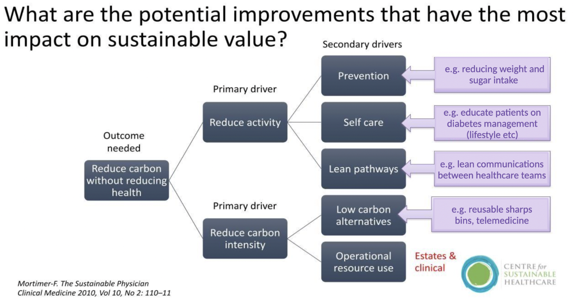

Prioritising improvement ideas table

Opportunity | Health Impact (0-3) | Environmental Impact (0-3) | Social impact (0-3) | Feasibility (0-3)
Staff training (E learning module) for clinicians regarding cultural differences in diet/religious occasions
Patient education regarding improving disease management (online information/apps in different languages)
Immediate referrals for complications via e-noting system warnings
Increased use of telemedicine (eg photographic surveillance for foot ulcers)
Your group improvement idea

