Worksheet 1 GP – Studying the system: environmental impacts

Activity 1 – Study the system for environmental impacts
Task A: Read the scenario below and look at the process map. What environmental resources do you think are currently being used because of the frequent readmissions in this patient group? Can you identify the resource which is a carbon hotspot?
Consider the environmental impacts/resources used at each step of the process map and write your answers in table 1 column 2 below. Once you have completed your list of resources, identify which one you think is the carbon hotspot (i.e.. the resource with the most intense concentration of GreenHouse Gas (GHG) Carbon emissions). Please appoint a scribe in your group and someone to feedback your answers ready for when you return to the whole group.
Task B: What data could be collected to measure the resources you have identified? Think how you could measure the total amount of resources you have identified. Write your answer in table 1 column 3.

Scenario
Rita is 53 years old. She was diagnosed with type 2 diabetes mellitus by her GP in 2015 and is now insulin dependent. She has no relevant medical history and drinks 7 units of alcohol a week. She is due for her annual diabetic review at her GP and as English is not her first language, Dr Shetty communicates with her in Hindi.

During the review, her blood pressure, height and weight is taken as well as bloods (HbA1c, lipid profile, U+Es and LFTs). She admits to poor compliance to insulin and lifestyle management prompting a referral to the Endocrine department at her local trust. As a result, Rita is suffering from a chronic foot ulcer and has to be seen by a district nurse fortnightly for redressing (26 times a year). She is currently on Trulicity 0.75mg injections and Dr Shetty is happy with this regimen. She travels 3km to and from the GP by taxi. She lives alone in a ground floor flat located within a busy city centre with poor access to green space.
You notice that Rita is a frequent attender of the GP with 5 presentations related to diabetic complications in the last year excluding her annual diabetic review. You discuss this case at the practice meeting where you discover many similar patients are reporting poor compliance to management and as a result presenting with complications of diabetes. To investigate this further, you decide to do an audit and discover that 200 insulin dependent diabetic patients that visit the GP 3 times a year are referred to tertiary services for foot ulcer related complications. You also notice that 8% drink more than the weekly recommended intake and 30% have a first language other than English.

[Look at the process map below]

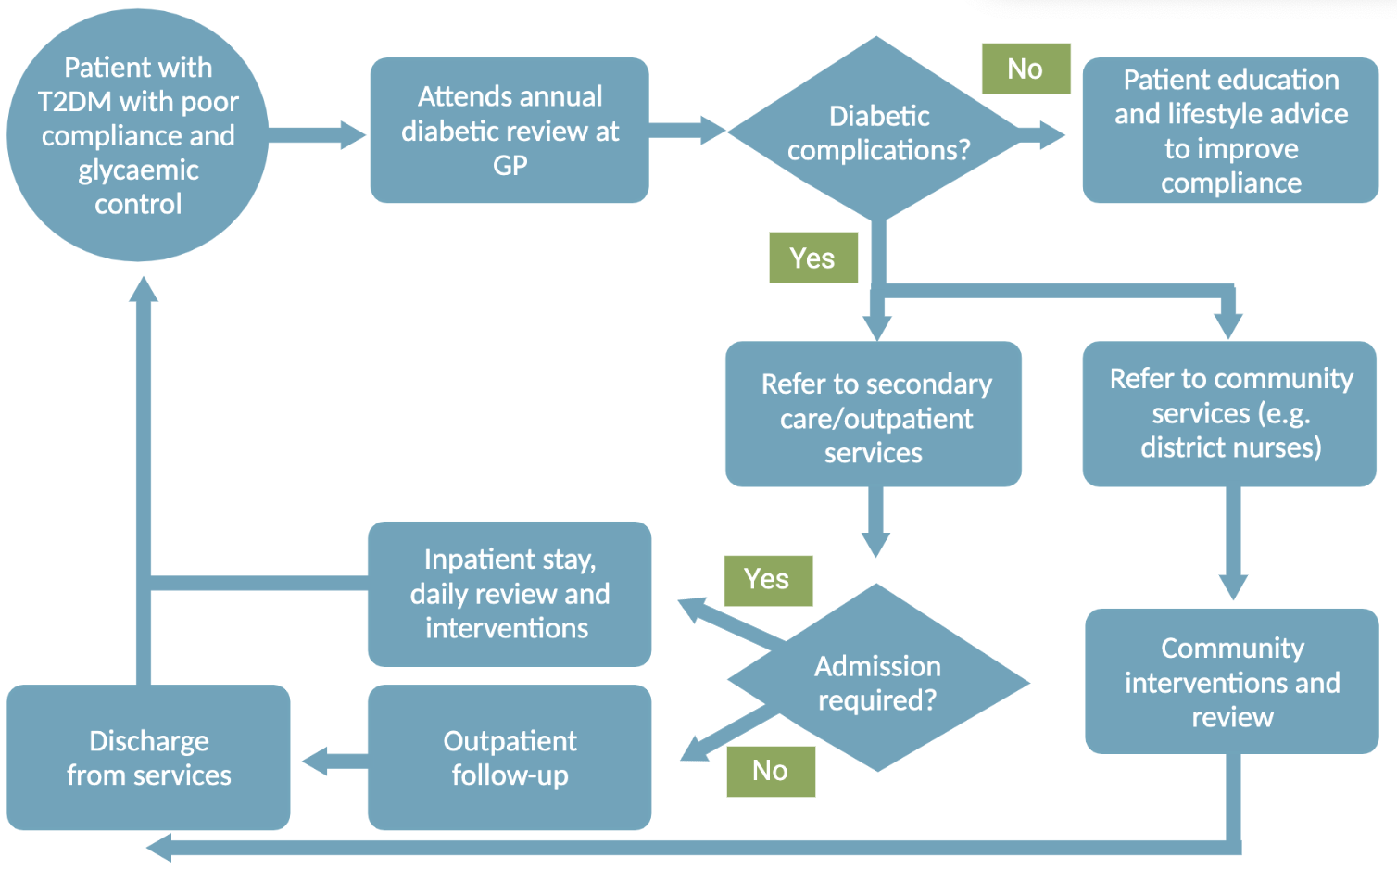

[Complete table 1. Resource use below]
Table 1. Resource use
Activity/Resource | Task A: What resources are currently being used? | Task B: What data is available/ could be collected?
1. Medical supplies
Medications | e.g insulin injections, | e.g.Pharmacy department
Anaesthetic gases / nitrous oxide
Propellant (MDI) inhalers
Medical & surgical equipment
Dressings
Diagnostic imaging & radiotherapy equipment & services
Other, specify…
2. Non-medical supplies

Office equipment, telecomms, computers & stationery
Furniture fittings
Provisions
Other, specify …
3. Travel
Staff travel
Patient and carer travel
4. Energy use
5. Water use
6. Waste disposal
7. Units of healthcare activity
Inpatient bed-day
Outpatient appointment
GP appointment
Surgical or other procedure

[Complete Activity 2. on the next page]

Activity 2 – Carbon footprinting in healthcare
Task: Using table 2. plus the equation and carbon emission factors below, in your groups try to work out the Carbon footprint of the following:
- 200 insulin dependent diabetic patients with complications attend the GP 3 times a year

Carbon footprint (kg CO2e) = Activity/resource use x GHG emissions factors

Table 2.
