Worksheet 1 OBGYN (Facilitator version 1.0) – Studying the system: environmental impacts Background information for Facilitators
When thinking about the environmental impact of any healthcare intervention, there are several broad categories to consider.
Carbon footprint: this refers to the amount of greenhouse gases (GHG) emitted directly or indirectly attributable to a process, product or organisation usually expressed in kg CO₂ equivalents. Elements of healthcare activity with a measurable carbon footprint include:
- Energy use on site (burning fuel for heating, electricity use for lighting, cooking and cleaning etc) o Release of anaesthetic gases / nitrous oxide o Travel (staff, patients, carers)
- Pharmaceuticals and medical equipment (supply chain emissions – from manufacture and distribution) o Non-medical equipment and supplies (supply chain emissions for furniture, IT equipment, laundry, etc.) o Food production o Waste disposal
Non-carbon impacts: A Carbon footprint is an important measure of environmental impact, but it is not the only one. Consider whether any of the following environmental impact categories apply to the Quality Improvement project, too:
- Air pollution: non-carbon pollutants from fossil fuel use or waste incineration (nitrogen oxides, particulate matter)
- Deforestation, landscape degradation, loss of biodiversity (mining and plantations for supply chains)
- Depletion of scarce natural resources, including fresh water
- Bio-accumulation and toxicity of chemicals entering the environment, often through water pollution (antibiotics, antidepressants, contraceptives, propofol)
- Plastic pollution from inadequate waste disposal systems / littering

Activity 1 – Study the system for environmental impacts
Task A: Read the scenario below and look at the process map. What environmental resources do you think are currently being used because of the frequent clinic appointments and extended admission needed for this patient? Can you identify one resource that you think is a carbon hotspot?
Consider the environmental impacts/resources used at each step of the process map and write your answers in table 1 column 2 below. Once you have completed your list of resources, identify which one you think is the carbon hotspot (i.e.. the resource with the most intense concentration of GreenHouse Gas (GHG) Carbon emissions).
Please appoint a scribe in your group and someone to feedback your answers ready for when you return to the whole group.
Task B: What data could be collected to measure the resources you have identified? Think how you could measure the total amount of resources you have identified. Write your answer in table 1 column 3.
Facilitator note: Encourage students to think about each step of the process map and fill out table 1 (They may not get time to think of all the examples in the time allocated to the activity). The main aim is that they consider each area in the resource table so they begin to develop a skill of spotting carbon hotspots (in this case Induction of Labour and the likely use of Entonox use, as well as the need for a C/S) and a holistic sustainability lens when studying the system before designing the improvement. This exercise is also designed to encourage students to think about where they could find out and measure the data in order to measure the improvement later on in the Quality Improvement Project (QIP) process.

Scenario
Farhana is a 34 year old primip who books at CSH University Hospital at 9+2 weeks gestation. At booking her risk factors are identified as; having a BMI of 36 (weight 96kg), being from a high risk ethnic group for GDM and having limited social support as a single mother-to-be with only her older sister residing in the UK 1 hour away. She works antisocial hours in the local supermarket full time and rents a single bedroom flat on the 3rd floor without lift access.
She is recommended to take Aspirin 150mg from 12 to 36 weeks, as well as take high dose Folic Acid and Vitamin D for the duration of her pregnancy. Booking bloods are taken, all of which return normal bar a borderline Hb of 116g/L. She is booked an OGTT for 24 weeks and put on a shared care pathway, which develops as follows:
- 12/40 Dating scan and combined blood test, all return low risk results
- 16/40 Consultant clinic, satisfactory review, booked serial scans for 28, 32, 36 +/-39 weeks
- 20/40 Anomaly scan, normal
- 24/40 OGTT, results raised for both fasting and 2 hours, referred to GDM clinic
- 25/40 Combined MW/GDM review. Given teaching session on dietary advice and instructions on monitoring her blood sugars
- 26/40 1 week GDM review, satisfactory BS readings, GDM now reviewed fortnightly
- 28/40 Consultant clinic. Satisfactory BS readings. Weight 106kg (BMI 40). US normal EFW 80th centile. Hb 98 g/L. Referred to anaesthetic clinic, commenced on 200mg FeSO₄ BD
- 32/40 Consultant clinic. Satisfactory BS readings. US EFW now between 90-97th centile
- 36/40 Consultant clinic. Abnormal BS readings. US EFW now >97th centile. Hb 112 g/L. Started on Metformin, recommended 37/40 sweep and 38/40 IOL
- 38/40 Inpatient IOL. Remains on AN ward or 48 hours before transfer to LW for augmentation & requires sliding scale. After a further 18 hours has a category 3 CS at 3cm for failed IOL.
- Remains on PN ward for 72 hours before discharge (delay in paperwork, hasty discharge when complete)
- Sent to MDAU at D4 by CMW due to wound infection and prescribed oral abx
Facilitator Note: The purpose of this scenario is to encourage students to think about what might be the best solutions to the inefficiencies of ante-natal care and the complications of pregnancy.
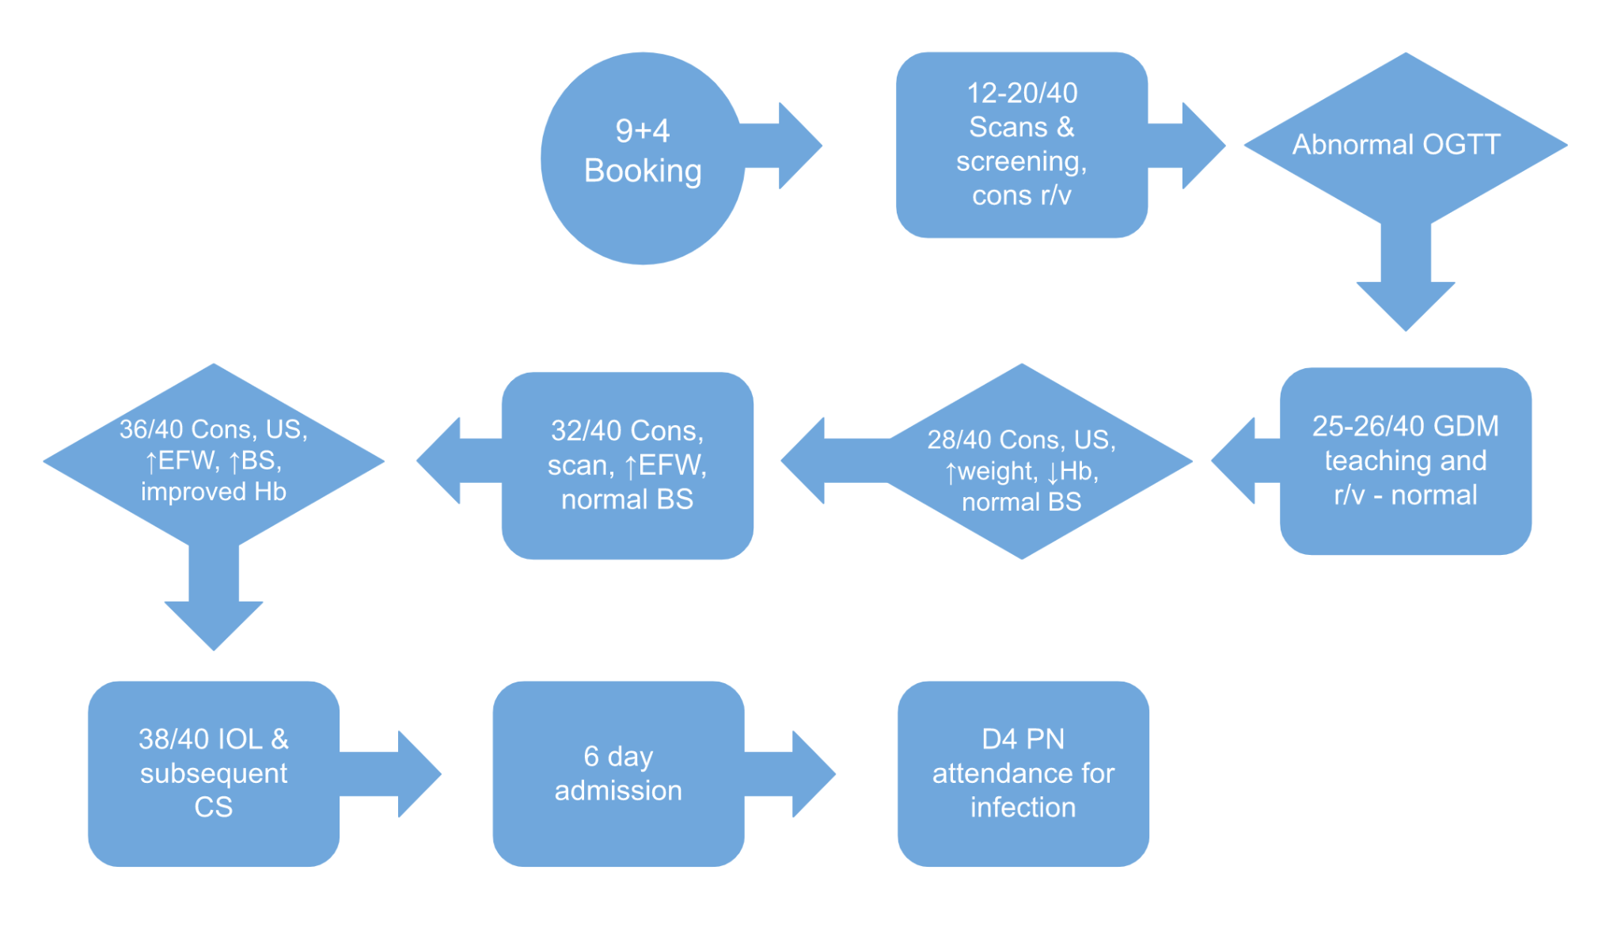
Table 1. Resource use
Activity/Resource | Task A: What resources are currently being used? | Task B: What data is available/ could be collected?
1. Medical supplies
Medications | Aspirin  Vitamin D  Folic Acid  Ferrous Sulphate  Metformin  Propess  Prostin  Syntocinon  Epidural - Bupivicaine, Fentanyl, cold spray  Lidocaine  Instillagel  Act Rapid  500ml 5% Dextrose x1  1L 0.9% Saline x3  Diclofenac  Paracetamol  Ibuprofen  Lactulose  Enoxaparin  Co-Amoxiclav | Pharmacy department
Anaesthetic gases / nitrous oxide | Entonox | Anaesthetic department
Propellant (MDI) inhalers | N/A | Pharmacy department
Medical & surgical equipment | Phlebotomy equipment (needle, tourniquet, blood bottles, gauze, tape) x8  Cannula & insertion pack x3  BS monitor & test strips  Staff PPE – Single-use masks, gloves, single-use plastic aprons, face shield/visors.  Covid19 tests, MRSA swabs.  Obs equipment (thermometer, dinamap, tape measure, couch roll, urine bottle & cup)  CS pack  Epidural insertion pack  Slip sheet  Sterile gloves  Gauze  Foley Catheter & insertion pack  Vaginal Assessment pack x8  Giving set  O₂ mask  Surgical drape  Surgical gowns  Hair net  TEDS  Balloon catheter for induction | Procurement department, Pathology department.
Dressings | CS wound dressing  Negative pressure dressing | Procurement

Diagnostic imaging & radiotherapy equipment & services | CTG machine  Ultrasound machine x5  Hand held doppler | Medical physics
Other, specify…
2. Non-medical supplies
Office equipment, telecomms, computers & stationery | Computers, paper notes, stationery, telephone | Health records department, IT department
Furniture fittings | Hospital bed, delivery bed, theatre table, chairs, table, sink, tissue dispenser | Procurement department
Provisions | Hospital meals x6 days, baby formula
Other, specify … | Hospital gown, slippers | Procurement/Laundry services
3. Travel
Staff travel | Community services/clinics, hospital obstetric team - high intensity of appointments
Patient and carer travel | Taxi/bus travel to and from hospital - high intensity of appointments
4. Energy use | Building energy – electricity, lighting, heating | Estates department
5. Water use | Drinking water  Washing  Cleaning | Estates department
6. Waste disposal | Clinical waste  Non clinical waste (domestic, recycling)  Sharps waste  Grey-water waste (bath, shower, sink and washing water)  Sewage | Estates department/Cleaning dept
7. Units of healthcare activity
Inpatient bed-day | 6 day stay
Outpatient appointment | 11 AN apts & 1 PN reattendance (+ routine PN visits/clinic)
GP appointment
Surgical or other procedure | 1 surgery (CS)

Activity 2 – Carbon footprinting in healthcare
Task A: Calculate the carbon footprint of travel associated with Farhana’s 12 AN appointments and 1 PN reattendance. Assume she has travelled by bus for 11 appointments and taxi for 2, and the average distance of travel is 10km (return trip).

Carbon footprint (kg CO2e) = Activity/resource use x GHG emissions factors

Activity | Carbon emission factor
Travel by car | 0.21656 kgCO2e / km
Travel by bus | 0.12721 kgCO2e / passenger.km

Workings:

Bus travel: 10 x 0.12721 = 1.2721 per return trip x 11 trips = 13.9931kg CO2e
plus
Taxi travel: 10 x 0.21656 - 2.1656 per return trip x 2 trips = 4.3312kgCo2e

Total = 18.3243kgCo2e

Task B: Using the Units of Healthcare Activity Emission Factors shown below, calculate the carbon footprint of Farhana’s clinic appointments and in-patient stay combined.

Units of Healthcare Activity | Carbon emission factor
Acute Sector Outpatient Appointment (including Pharmaceuticals) | 18kgCO2e/appointment
Inpatient bed day (low intensity ward) | 37.9kg/CO2e/day
Surgical Procedure (66 minutes) | 35.1kgCO2e

Workings:
11 Ante-natal and 1 Post-natal Out-patient appointment: 12 x 18 =
plus
6 Inpatient bed days: 6 x 37.9 =
plus
1 Surgical procedure: 1 x 35.1 = 35.1kgCO2e

Total =

Facilitator note: This activity shows one way to calculate a carbon footprint using the carbon emission factor for units of healthcare activity e.g. one antenatal appointment.
The non-carbon method: A quick and simple way of measuring the environmental impact without doing a carbon footprint is to make a list of all the resources currently used and measuring/recording the amount used (before implementing an improvement idea) and then list and measure them again after implementing the improvement to compare if the resource use has increased or decreased. If it has decreased then the environmental impact has been reduced.
.

