Measuring Environmental Impact

Carbon Footprinting
Though we have an estimate of the NHS’s carbon footprint overall, the carbon impact of quality improvement projects is not usually routinely measured. In order for the NHS to reduce its greenhouse gas emissions to net zero by 2050, carbon needs to become an additional currency alongside money, understood by all working in the health system.

What is a carbon footprint?
A carbon footprint is the sum of greenhouse gas (GHG) emissions attributable to a given process. Six different types of gases are commonly included; as each has a different global warming potential, the quantities are expressed in “carbon dioxide equivalents” (CO₂e). This is shown in Table 1 below.

The impact of a QI project on the NHS carbon footprint can be estimated by converting data for example on services, consultations, hospital admissions, travel and other activities into kilograms of CO₂e.

Carbon footprint (kg CO₂e) = activity or resource use x GHG emissions factors

A GHG emissions factor is the average emission rate of a given source. Emissions factors can be found in databases, some of which are publicly accessible (e.g. those published by the UK Government Department of Business, Energy & Industrial Strategy, BEIS)

Table 1: Global warming potential of some GHGs used in healthcare:

Greenhouse gas (GHG) | Healthcare use | 100-year global warming potential
CO₂e | Embedded carbon from energy use in buildings, travel and supply chain | 1
Hydrofluorocarbons (HFCs) | Anaesthetic vapours, inhaler propellants e.g. MDI’s  (also refrigerants) | 130 (sevofluorane)  510 (isofluorane)  2540 (desfluorane)
Nitrous oxide (N₂O) | Anaesthetic agent | 298

Planning your carbon footprint study

Step 1. Define the goal and scope of your study

Do you want to understand the make-up of the carbon footprint of the entire service or just to quantify the impact of your specific QI project? Will you want to be able to compare with other projects or services? Think about how you will use the study results as this will affect the data you choose to collect.

Step 2. Identify the resource that you will measure (set boundaries, create inventory)

This will be based on: which resources you expect to change as a result of your project, the practicalities of data collection, and the available emissions factors for conversion into CO₂e.

First consider the resources/activities required to deliver the service before and after your change. These may include, patient and staff travel, energy, medications, medical equipment/supplies, non-medical equipment/supplies. Tables to do this can be found in the Studying the System Section. You can use this table to review the potential impact of your change on different categories of resource use – and to consider how it could be measured. Include any resources needed to introduce the change – e.g. new equipment.

It is also important at this stage to consider what emissions factors you will apply in Step 4, in order to convert your data into CO₂e (see sample emissions factors at end of the document). You are unlikely to have emissions factors available for individual medications or items of medical equipment and may therefore need to track changes in financial spend for these categories. Depending on your QI project, it might be easiest to estimate the carbon impact from changes in units of healthcare activity, such as outpatient appointments, A&E attendances, inpatient bed-days.

Finally, write down what you are including in your carbon footprint study and what you are not. Without this, it is not possible for others to interpret your results or make comparisons.

Step 3. Measure the resource utilisation (collect data)

Gather the data for each resource categories that you have identified and calculate the change in utilisation as result of your QI project.

Step 4. Attribute a carbon cost or footprint to the resources used (apply emissions factors)

Using Table 2 ‘Calculating change in carbon footprint’ in the Measuring environmental impacts form, enter the data you collected in Step 2 on activity/resource and the emissions factor you have selected – now multiply these together and add up the results!

Example
At one of the hospital trusts in England, cannulae were inserted routinely in patients attending A&E. All cannulae were fitted with a bionector, for infection control purposes. However, an audit found that many cannulae were not used or used inappropriately. After deciding to reduce cannulation, the hospital reduced the number of cannulae use by 105 and the number of bionector use by 98 in one week. How much carbon emissions did the hospital save?
105 fewer cannulae were used (Cost: £1.80, weight: 0.061kg)
98 fewer bionectors were used (Cost: £3.51, weight: 0.01kg)
Carbon emissions factor
Medical/surgical equipment: 0.3 kgCO₂e/£
Waste incineration: 220 kgCO₂e/tonne
Calculation: Carbon emissions saved
(105 x 1.80 x 0.3) + (105 x 0.061/1000 x 220) = 58.11 kgCO₂e
(98 x 3.51 x 0.3) + (98 x 0.01/1000 x 220) = 103.41 kgCO₂e
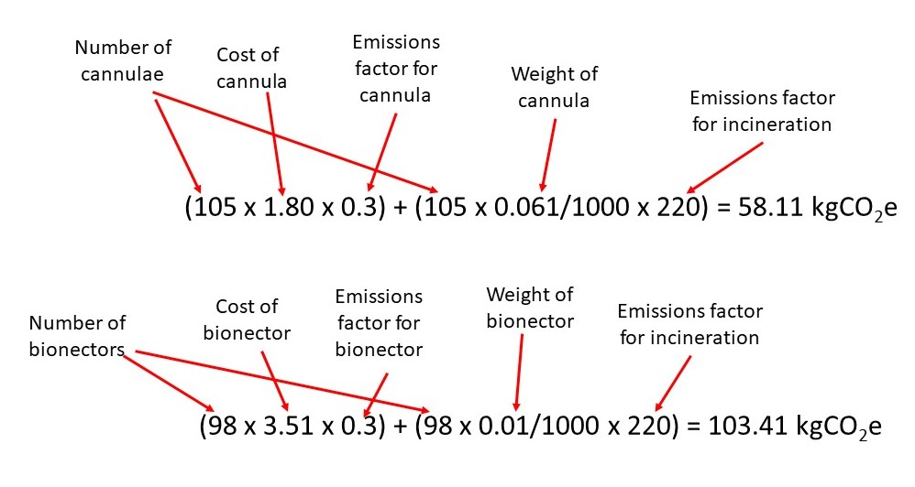

In total the A&E department saved 161.52 kgCO₂e in one week by reducing cannulation. Over a year the GHG emissions savings would amount to 8,399 kgCO₂e.

Table 1. Resource use
You can use this table to review the potential impact of your change on different categories of resource use – and to consider how this could be measured. You may be approaching this looking at individual items or at a larger scale such as units of healthcare. Both are included in this table.
Resource |  | Potential impact of your service change | What data is available/ could be collected?
1. Medical  Supplies | Medications
 | Anaesthetic gases / nitrous oxide
 | Propellant (MDI) inhalers
 | Medical & surgical equipment
 | Dressings
 | Diagnostic imaging & radiotherapy equipment & services
 | Other, specify…
2. Non-Medical  Supplies | Office equipment, telecomms, computers & stationery
 | Furniture fittings
 | Provisions
 | Other, specify …
3. Travel | Staff travel
 | Patient and carer travel
4. Other Resources | Energy use
 | Water use
 | Waste disposal
5. Units of healthcare activity | Inpatient bed-day
 | Outpatient appointment
 | GP appointment
 | Surgical or other procedure

Table 2. Calculating change in carbon footprint
Activity/resource | Activity change: change in each activity/ resource over defined period | Emissions factor (kgCO₂e per [unit should match units for activity/resource]) | Carbon impact: activity change x emissions factor (kgCO₂e)
1.
2.
3.
4.
5.
 |  | Total change in carbon footprint (kgCO₂e):

Appendix
Some useful GHG emissions factors:
- Medical Supplies
GHG emissions factors for NHS financial spend on:
- Pharmaceuticals: 0.155 kgCO₂e / £
- Medical equipment: 0.3 kgCO₂e / £
- Medical equipment/instruments (NHS Trusts): 0.41 kgCO2e/ £
- Dressings: 1.54 kgCO₂e / £
- Diagnostic imaging & radiotherapy equipment & services: 0.3 kgCO₂e / £
- Dental & optical equipment: 0.3 kgCO₂e / £
- Laboratory equipment & services: 0.3 kgCO₂e / £
- Chemical & Reagents: 0.76 kgCO₂e / £
- Patients appliances: 1.54 kgCO₂e / £
- Staff clothing: 0.29 kgCO₂e / £
- Patients clothing & footwear: 0.29 kgCO₂e / £
- Bedding linen & textiles: 0.32 kgCO₂e / £
Source: Carbon factors Greener NHS Team 2020-21

Anaesthetic gases
GHG emissions factors per litre of:
- Desflurane: 3,721.1 kgCO₂e / litre
- Isoflurane: 762.96 kgCO₂e / litre
- Sevoflurane: 197.86 kgCO₂e / litre
- Nitrous oxide: 0.559 kgCO₂e / litre
Nitrous oxide with oxygen 50/50 split: 0.278 kgCO₂e / litre
Source: Sustainability Reporting Template 2018/19 (Sustainable Development Unit) http://www.sduhealth.org.uk/delivery/measure/reporting.aspx

Metered dose inhalers
GHG emissions factors per inhaler:
- Large volume inhaler, e.g. Ventolin: 24 kgCO₂e / inhaler
- Small volume inhaler, e.g. Salamol: 10 kgCO₂e / inhaler
Source: Wilkinson AJK et al. Costs of switching to low global warming potential inhalers. An economic and carbon footprint analysis of NHS prescription data in England. BMJ Open Access. Sep 2019. https://bmjopen.bmj.com/content/bmjopen/9/10/e028763.full.pdf

- Non-medical supplies
GHG emissions factors for NHS financial spend on:
- Office equipment, telecommunications, computers & stationery: 0.53 kgCO₂e / £
- Furniture fittings: 0.48 kgCO₂e / £
- Provisions: 0.97 kgCO₂e / £
- Hotel services, equipment, materials & services: 0.49 kgCO₂e / £
- Building & engineering products & services: 0.49 kgCO₂e / £
- Gardening & farming: 2.68 kgCO₂e / £
- Hardware crockery: 0.58 kgCO₂e / £
- Recreational equipment & souvenirs: 0.28 kgCO₂e / £
- Staff & patient consulting services & expenses: 0.31 kgCO₂e / £
- Food and catering: 0.64 kgCO2e/£
Source: Carbon factors Greener NHS Team 2020-21

PPE
- Single glove: 0.026 kgCO2e / item
- Cup fit FFP respirator: 0.125 kgCO2e/item; duckbill FFP respirator 0.076 kgCO2e / item
- Type IIR surgical mask: 0.02 kgCO2e, type II surgical mask: 0.013 kgCO2e / item
- Face shield: 0.231 kgCO2e / item
- Apron: 0.065 kgCO2e / item
- Single-use gown: 0.905 kgCO2e / item
Source: Rizan C, Reed M, Bhutta M. Environmental impact of Personal Protective Equipment supplied to health and social care services in England in the first six months of the COVID-19 pandemic. Journal of the Royal Society of Medicine; 0(0) 1–14, DOI: 10.1177/01410768211001583, https://journals.sagepub.com/doi/full/10.1177/01410768211001583

- Travel
Travel – average emissions by mode of transport:
- Bus: 0.12721 kgCO₂e / passenger.km
- Car: 0.21656 kgCO₂e / km
- Train: 0.04282 kgCO₂e / passenger.km
- Regular taxi: 0.18508 kgCO₂e / passenger.km
- Black cab: 0.25416 kgCO₂e / passenger.km
Source: Government emission conversion factors for greenhouse gas company reporting: full set 2021.
Greenhouse gas reporting: conversion factors 2021 - GOV.UK (www.gov.uk)
(accessed Aug 2021)

- Other Resources
Energy
- Electricity use (UK): 0.2913 kgCO₂e / kWh
- Natural gas: 0.21451 kgCO₂e / kWh
Source: Government emission conversion factors for greenhouse gas company reporting 2021. https://assets.publishing.service.gov.uk/government/uploads/system/uploads/attachment_data/file/1005677/conversion-factors-2021-full-set-advanced-users.xlsm (accessed Aug 2021)

Water use
- Water use: 366.6 kgCO₂e / million litres; 0.3666 kgCO₂e / m3
Source: Government emission conversion factors for greenhouse gas company reporting 2021. https://assets.publishing.service.gov.uk/government/uploads/system/uploads/attachment_data/file/1005677/conversion-factors-2021-full-set-advanced-users.xlsm (accessed Aug 2021)

Waste disposal:
• Recycling reusable instruments: 21 kgcO2e / tonne
• Recycling reusable surgical linens: 21 kgCO2e / tonne
• Recycling batteries: 65 kgCO2e / tonne
• Low temperature incineration with energy for waste - dry mixed recycling, domestic waste : 172 kgCO2e / tonne
• Low temperature incineration with energy for waste – non-infectious offensive waste: 249 kgCO2e
• Autoclave decontamination plus Low temperature incineration with energy for waste – infectious waste: 569 kgCO2e / tonne
• High temperature incineration – clinical waste, medicinal contaminated sharps, anatomical waste, medicinal waste 1074 kgCO2e/tonne
Source: Rizan C, Bhutta M, Reed M, Lillywhite R. The carbon footprint of waste streams in a UK hospital. Journal of Cleaner Production 286 (2021) 125446. https://www.sciencedirect.com/science/article/abs/pii/S0959652620354925

- Units of healthcare activity
Outpatient appointments in GP and acute sectors (includes travel):
- GP appointment: 6 kgCO₂e (including pharmaceuticals is 18 kgCO₂e)
- Acute sector outpatient appointment: 23 kgCO₂e
Source: Carbon Hotspots update for the health and care sector in England 2015 (Sustainable Development Unit, 2016) http://www.sduhealth.org.uk/documents/publications/2016/Carbon_Footprint_summary_HCS_hotspots_2015_final.pdf (see “Service Type Carbon Intensities” table p5)
https://www.pssru.ac.uk/project-pages/unit-costs/unit-costs-2019/

- Inpatient bed day – low-intensity ward – 37.9 kgCO₂e/ bed day
- Inpatient bed day – high-intensity ward – 89.5 kgCO₂e/ bed day
- A&E (emergency department) visit: 13.8 kgCO₂e
- Surgical procedure (66 minutes): 35.1 kgCO₂e
Source: Care pathways guidance on appraising sustainability (Sustainable Development Unit, 2015) Available from: http://www.sduhealth.org.uk/areas-of-focus/carbon-hotspots/pharmaceuticals/cspm/sustainable-care-pathways-guidance.aspx

